CGI-Testing Server(36 server) Bug List:

1. In Reports-ACH Transaction-Action button is present in wrong position and also while search a name in search box, search functionality is not working.

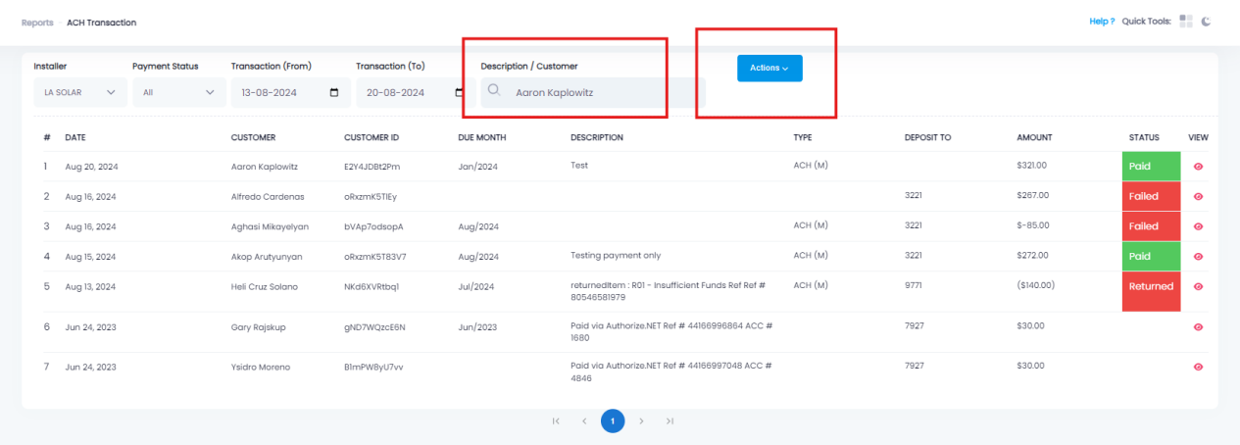

1. In Reports-Invoice Log-CLick edit button on any customer-Click Action button- After click download invoice button page gets crashed.

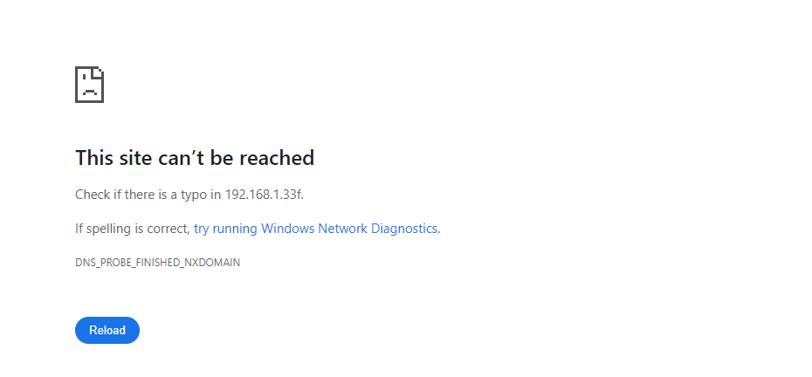

1. In Reports-Invoice Log-Table alignment is not proper.

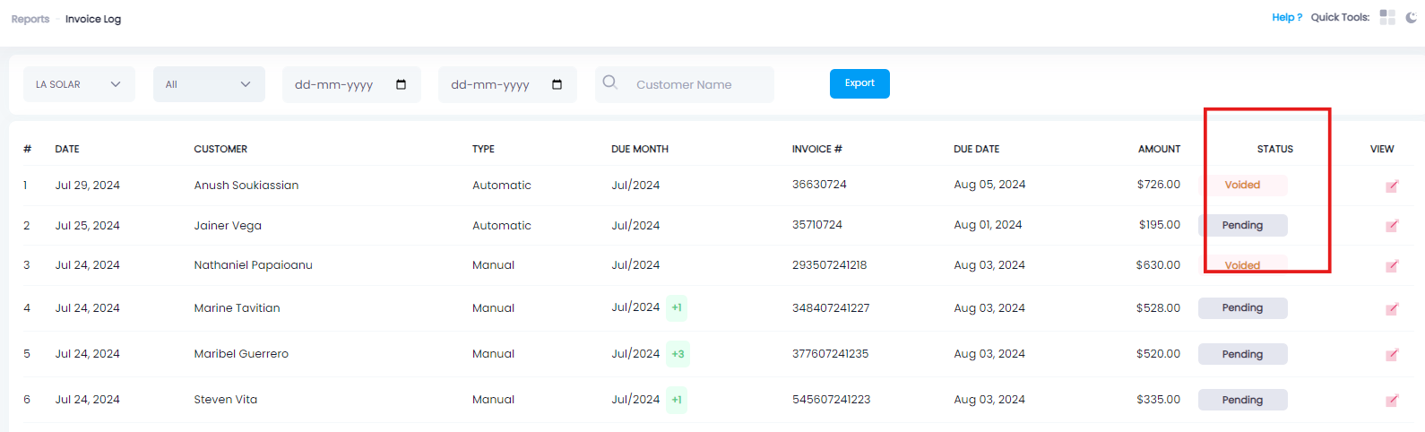

1. In Admin-Help-Click Add symbol-In Add Question page, In Answer field typing area text box outline is noot easy to visible.

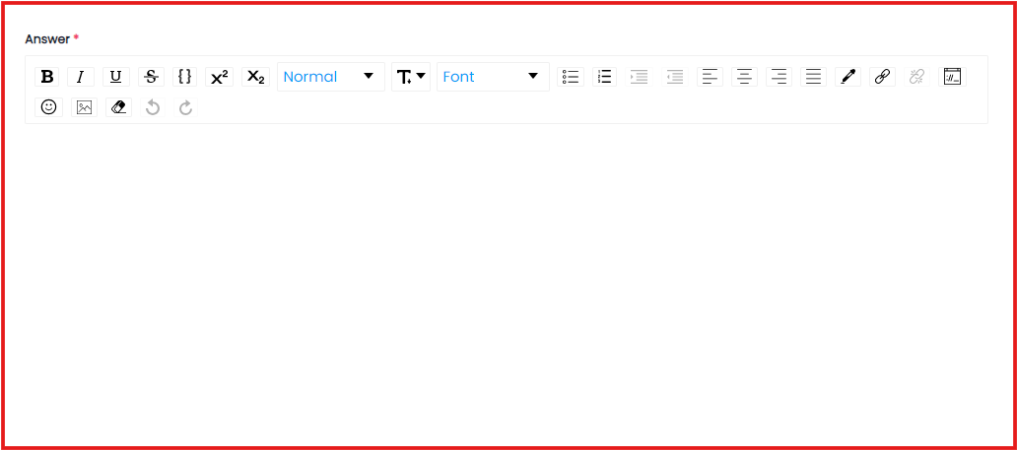

1. In Admin-Help-Click Add symbol-In Add Question page,In Answer field, when I click “Embedded” button, box is opened over the screen

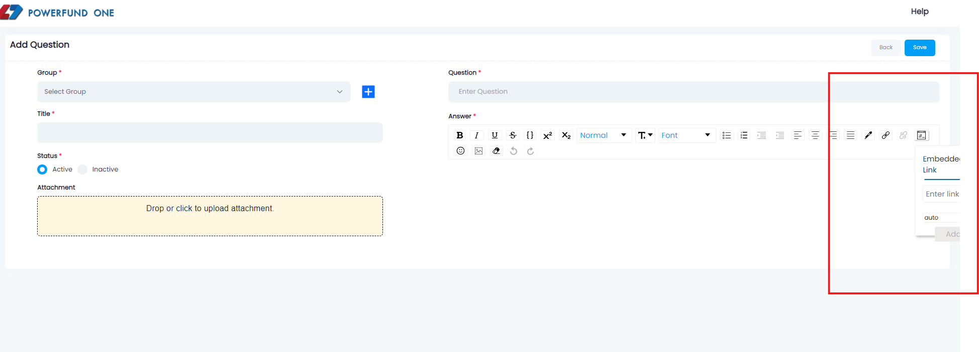

1. In Admin-Help-Click Add symbol-Click add group button-When enter valid details and click save button, details gets saved but two success message is displayed.

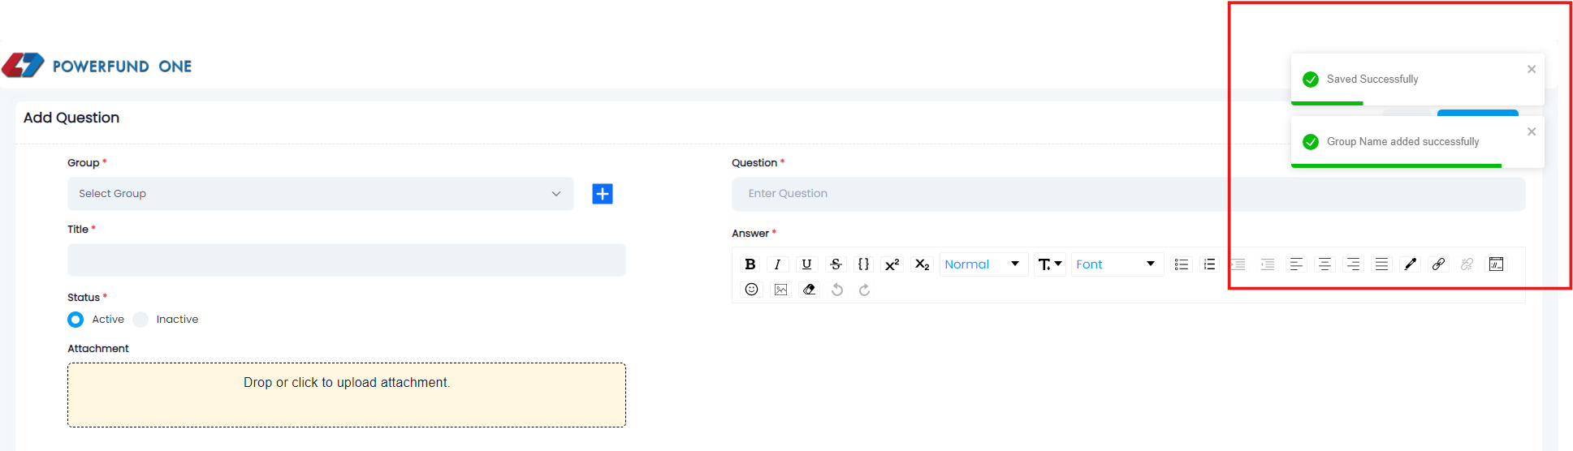

1. In Admin-Help-Click Add symbol-Click add group button-Existing data gets saved.

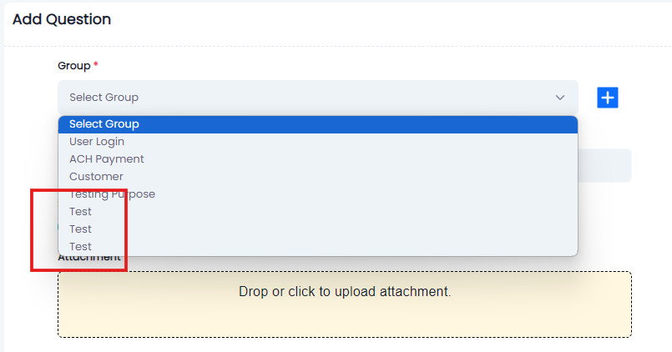

1. In Admin-Help-Filter option is not working.

